Pediatric and adolescent midshaft clavicle fractures can generally be treated nonoperatively, with a brief period of sling immobilization followed by therapy to regain range of motion and strength. Outcomes after nonoperative treatment of midshaft clavicle fractures are comparable to operative treatment at both mid- and long-term follow-up in pediatric and adolescent patients. (FACTS study 2022).

**Frequently Asked Questions:**

**When would you have surgery vs. non surgical intervention**?

Operative treatment is more likely to be considered in specific situations. If there is an open fracture, or if there is skin tenting/compromise, surgery is likely necessary. The lifestyle of the patient is heavily considered in the decision for surgical vs. nonsurgical treatment.

With surgery, the patient may be able to have more mobility and activity during the recovery period. Sports and high risk/impact activities are NOT possible, even with surgical treatment.

**What are the risks of surgery?**

With this surgery, there is a risk of infection at the surgical site. Patients also describe pain or symptoms related to the hardware used for fixation of the fracture, which might require secondary surgery to remove the implants.

**What are the risks of NOT having surgery for your clavicle fracture?**

Clavicle *nonunion* is a possible, but uncommon complication, especially in pediatric patients. This means that the bone hasn’t healed fully.

A *malunion* occurs when a fractured bone heals in an abnormal position or alignment, which can lead to impaired function of the bone or limb.

**What is your recovery timeline Surgery vs Non Surgical?**

The timeline of recovery varies person to person, however with surgical intervention your recovery timeline is approximately 6-8 weeks, while non-surgical recovery is approximately 8-12 weeks. With either course of treatment, long term outcomes (strength, range of motion, etc.) are equivalent.

**Should I be worried about if my clavicle bone fracture is displaced/overlapping?**

Traditionally it is ok for there to be up to 2 cm of overlap with the clavicle fragments. During the bone remodeling process, your clavicle’s bone cells will elongate the clavicle's shaft back to roughly its original length.



**What hardware is used for Clavicle surgery?**

Most clavicle fractures are fixed with a plate and screw construct. This is designed to ensure optimal alignment of the clavicle fragments.

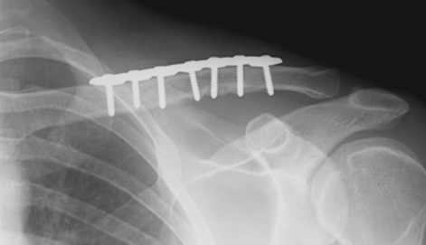

**What does the bone remodeling process look like without surgical intervention?**

It is important to understand that “clinical healing” is more significant than “x-ray healing”. X-Rays are a diagnostic tool to assess the progress of healing in a fracture, however your body will heal at a greater rate than can be demonstrated on an x-ray. As new bone forms, the fragments will unite together. Over time (6-12 months), the bone remodels, to restore its typical shape, length, and alignment. Without surgery, there may always be a subtle bump where the bone was broken.